DAILY ONLINE ACTIVITIES SUMMARY

|  |  |  |  |  |  |  |  |
| --- | --- | --- | --- | --- | --- | --- | --- |
| **Date:** | **22/05/2020** | | | **Name:** | | **JASLINE SHARON TAURO** | |
| **Sem & Sec** | **4th sem, A Section** | | | **USN:** | | **4AL18CS029** | |
| **Online Test Summary** | | | | | | | |
| **Subject** | | **OPERATING SYSTEMS** | | | | | |
| **Max. Marks** | | **30** | | | **Score** | **22** | |
| **Certification Course Summary** | | | | | | | |
| **Course** | **CYBER SECURITY ESSENTIALS** | | | | | | |
| **Certificate Provider** | | | **Cisco Network Company** | | **Duration:**  **3 HRS** | |  |
| **Coding Challenges** | | | | | | | |
| **Problem Statement: 1)** Write a C or Java program to implement round robin type of process scheduling.  2) Write a C Program to implement various operations on Singly Linked List Stack | | | | | | | |
| **Status: DONE** | | | | | | | |
| **Uploaded the report in GitHub** | | | | | **YES** | | |
| **If yes Repository name** | | | | | [**https://github.com/jaslinesharontauro/C_Prgms**](https://github.com/jaslinesharontauro/C_Prgms) | | |
| **Uploaded the report in slack** | | | | | **YES** | | |

**Online Test Details: (Attach the snapshot and briefly write the report for the same)**

**Certification Course Details: (Attach the snapshot and briefly write the report for the same)**

**Coding Challenges Details: (Attach the snapshot and briefly write the report for the same)**

**1.ONLINE TEST DETAILS:**

**Today we had assessment in the subject OPERATING SYSTEM. It was based on first module of this subject. There were total 30 number of questions of ONE mark each.**

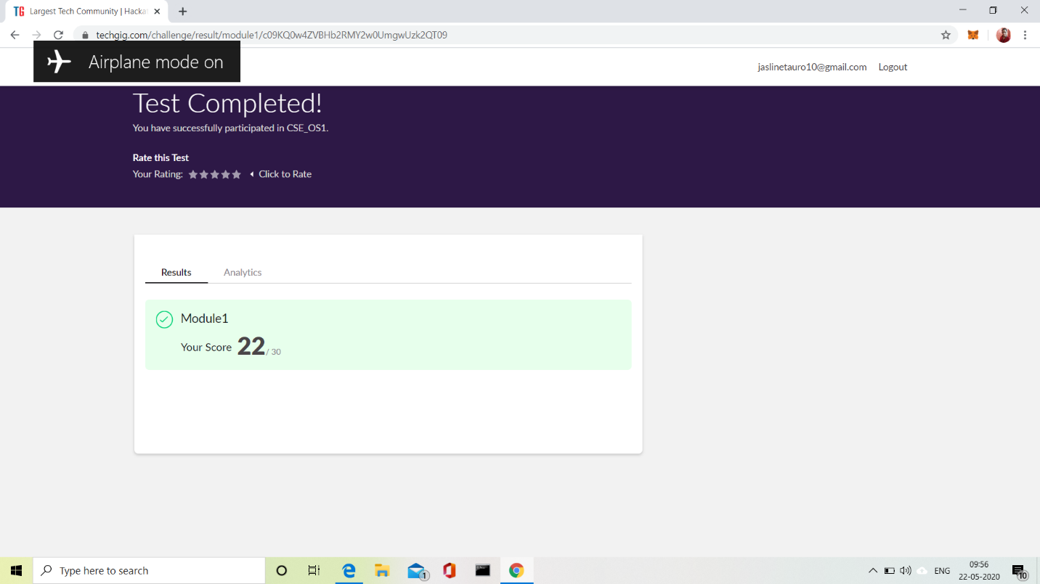

**2.CERTIFICATION COURSE DETAILS:**

**Today I have done the course Cyber Security Essentials. It includes following topics:**

* The characteristics of criminals and heroes in the cybersecurity realm.
* The principles of confidentiality, integrity, and availability as they relate to data states and cybersecurity countermeasures.
* The tactics, techniques and procedures used by cyber criminals.
* How technologies, products, and procedures are used to protect confidentiality.
* How technologies, products, and procedures are used to ensure integrity.
* How technologies, products, and procedures provide high availability.
* How cybersecurity professionals use technologies, processes, and procedures to defend all components of the network.
* 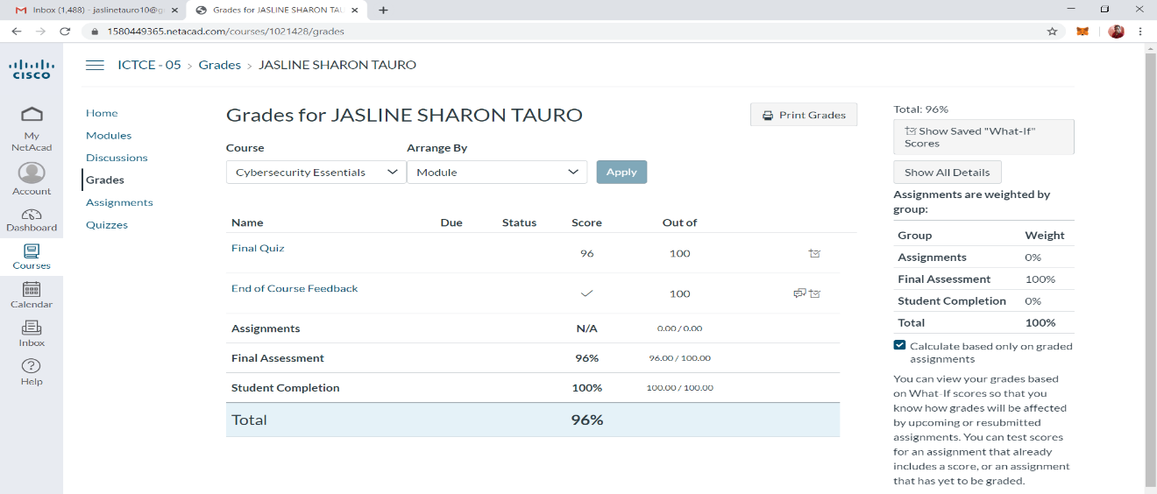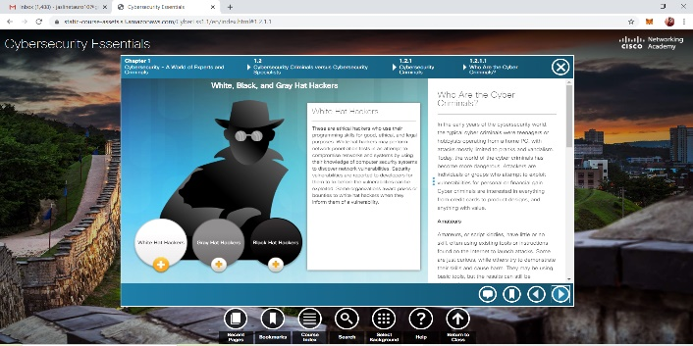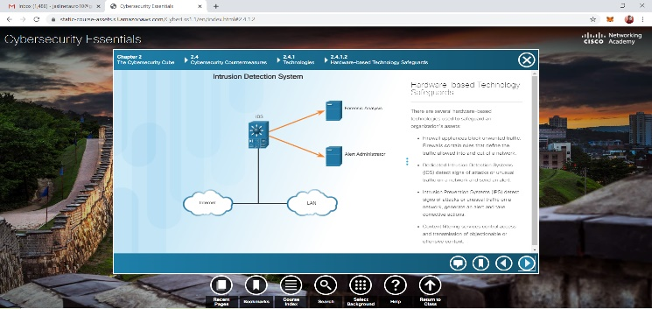The purpose of laws related to cybersecurity.

**3.CODING CHALLENGES DETAILS:**

**Problem statement 1:**

Write a C or Java program to implement round robin type of process scheduling.  
Input: Process with burst time, arrival time and specify the time quantum  
Output: Processes scheduled based on the round robin type of scheduling, with its average waiting time.

**Solution: Uploaded it in GitHub**

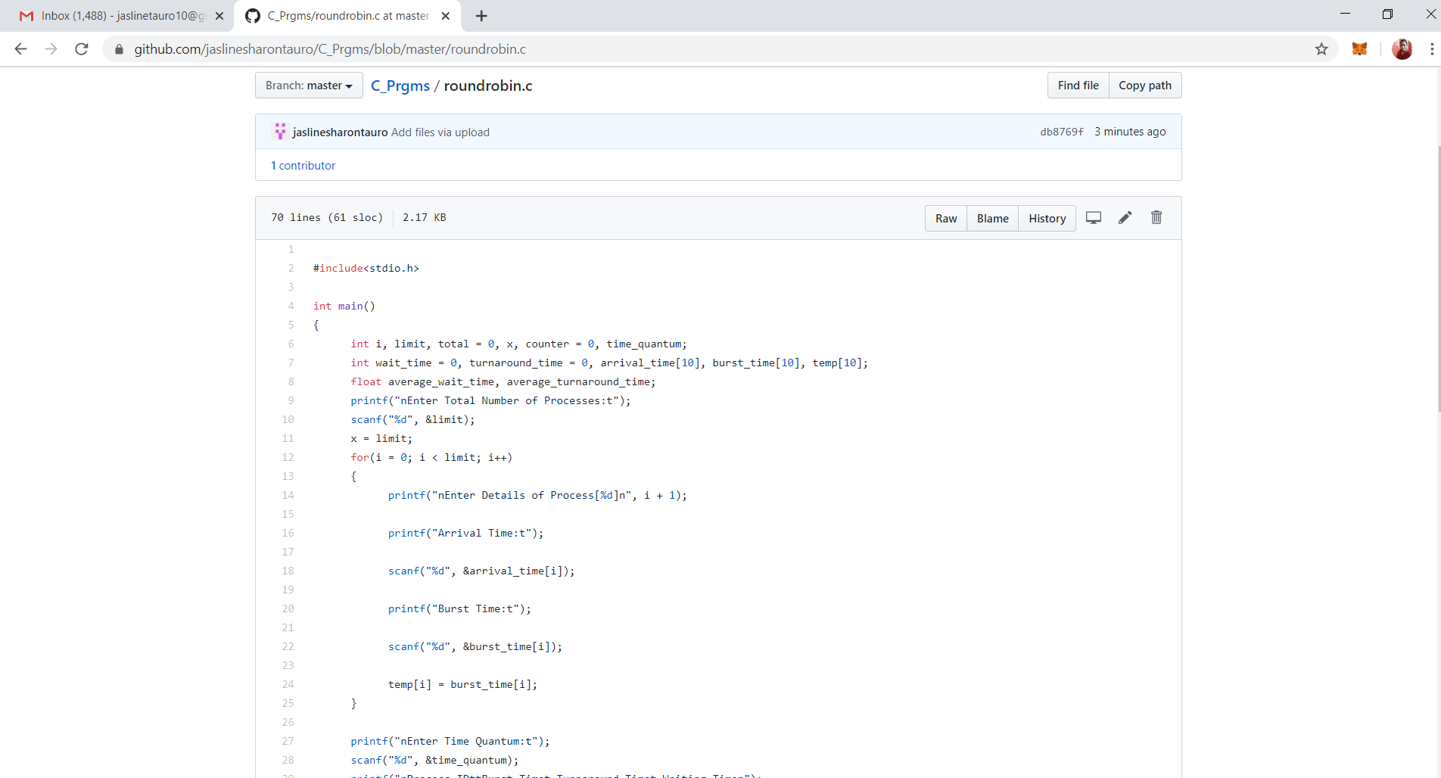

**Problem statement 2:**

Write a C Program to implement various operations on Singly Linked List Stack

Hint: First Create a Singly Linked List Stack with the node corresponding to First Element is the base of the stack; and its link field must be always Null.  
When you push First Element, it is the First and it is Base of the stack. Its Link must be Null. top pointer pointing to First. (top = First)  
When you push any element, (No need of checking Stack full case because SLL is dynamic) Create a new node called temp using malloc function and insert the a number into Data field, and Link field must be pointing to top; and move the pointer top to point to temp.  
When you pop, First check for stack Empty. if First == NULL, then Stack Empty. If it is not empty, the pointer temp must be pointing to top. Move the pointer top to top->link. delete temp.  
When you display the stack element, First Check for Stack Empty as in pop operation. If it is not empty, display all the elements of current stack starting from top to First. 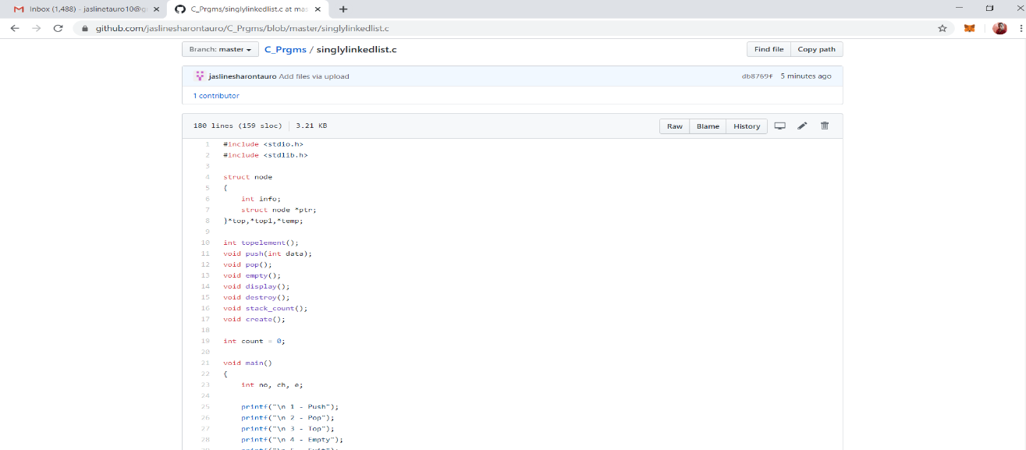

**Solution: Uploaded it in GitHub**